August 19, 2007 | 12th Sunday after Pentecost | 10:45 a.m.

Prelude and Lighting of the Candles

*Choral Call to Worship | “Holy Spirit, Thou Art Welcome”
Holy Spirit, thou art welcome in this place, Holy Spirit, thou art welcome in this place;
Omnipotent father of mercy and grace, Thou art welcome in this place.

Welcome, Announcements, and Passing of the Pew Pads

*Greeting | Psalm 118:24
This is the day that the Lord has made. Let us rejoice and be glad in it.

* Call to Worship
Out of the blue God comes to us.
In the midst of turmoil Jesus walks toward us.
As darkness closes in, the Spirit lights a way for us.
Out of the blue, Jesus comes through.
When times are tough, God can be enough. As questions arise, the Spirit is wise.
Let us raise our voices in song. May our praise be loud and strong.

*Hymn 701 | “When We All Get to Heaven”

* Opening Prayer
God of love and peace, send us as witnesses to your kingdom, and fill our hearts with joy in your promise of salvation. With your spirit accompanying us on our life's journey, may we spread your peace in all the world, through your son Jesus Christ, our Savior and Lord. Amen.

*The Peace 8 The peace of the Lord be with you always. And also with you.
Let us greet one another with signs of God’s reconciliation and love.

Worship with Our Tithes and Offerings

*Doxology 95 | “Praise God from Whom All Blessings Flow” | Old 100th
Prayers of the People

Anthem

Prayer for Illumination 6
Lord, open our hearts and minds by the power of your Holy Spirit, that, as the Scriptures are read and your Word proclaimed, we may hear with joy what you say to us today. Amen.

Epistle Lesson | Galatians 5:13-26
This is the Word of God for the people of God. Thanks be to God.

Sermon | The Wilderness Walk | Debbie Measmer

*Hymn 431 | “Let There be Peace on Earth” | World Peace

*The Apostles’ Creed 7
I believe in God, the Father Almighty, creator of heaven and earth.
I believe in Jesus Christ, his only Son, our Lord, who was conceived by The Holy Spirit, born of the Virgin Mary, suffered under Pontius Pilate, was crucified, died and was buried: he descended to the dead. On the third day he rose again: he ascended into heaven, is seated at the right hand of the Father, and will come again to judge the living and the dead.
I believe in the Holy Spirit, the holy catholic church, the communion of saints, the forgiveness of sins, the resurrection of the body, and the life everlasting. Amen.

*Hymn 370 | “Victory in Jesus” | Hartford

*Blessing 11

* Choral Benediction | “He Is Lord” | He Is Lord
He is Lord, He is Lord. He has risen from the dead and He is Lord.
Every knee shall bow, Every tongue confess That Jesus Christ is Lord.

Visitors: A warm welcome to Stony Hill. Please sign our guest book in the narthex, and include your mailing address. There are also guest cards in the pews. Join us again soon!

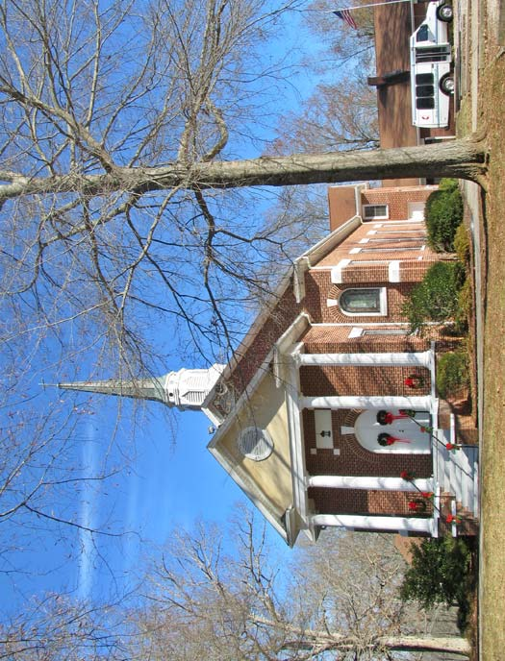
Invitation to John. On Tuesday, August 28, at 9 am in the fellowship hall and 7 pm at the parsonage, we will begin the 11-week Disciple study on the Gospel of John. If you would like to participate, or want a book for your personal study, please let Pastor Mary know. Books are $9.00.
STONY HILL UNITED METHODIST CHURCH
28996 Stony Hill Road
Albemarle, North Carolina 28001

Stanly County Christian Ministries: Please bring canned fruit for those less fortunate during August. Receptacles are in the narthex and in the hall outside the choir loft.

Flowers are placed in the sanctuary in celebration of God’s love for us and in memory of Virginia and Talmage Stoker.

Memorial Gift. We have received a very generous anonymous donation in memory of Talmage and Virginia Stoker.

Thanks to Phil Lowder for developing a web site for Stony Hill. The Mission Camp photos are now posted. Please check it out at http://www.infobucket.com/shumc/

Every Week at Stony Hill
Sunday 9:45 am, Sunday School for all ages; 10:45, Worship
Monday 6:30 pm, Welcome Bible Study
Wednesday 8:00 am, Breakfast Bunch at Hal’s; 7:00 pm, Choir
Thursday 6:30 pm, Boy Scouts, Fellowship Hall
7:00 pm, Disciple Bible Study at Lynne Terry’s

Coming Up
Sat. Aug. 25 10:00 am, District UMW Annual Meeting at Peachland UMC
Tue. Aug. 28 7:00 pm, Finance Meeting
UMMen 7:30 am, Third Saturday Breakfast Meeting every month

Serving Today
Greeters Sylvia Burris and Phyllis Huneycutt Piano Patty McCormick
Counters Kay Pope and Jane Burris Organ Carolyn Helms
Ushers Mike O’Neill and Jim Measmer Sound Jim Measmer
Acolytes Jasmine Benson and Cortney Germain Pastor Mary Lautensleger
Speaker Debbie Measmer Lector Barbara Stoker

